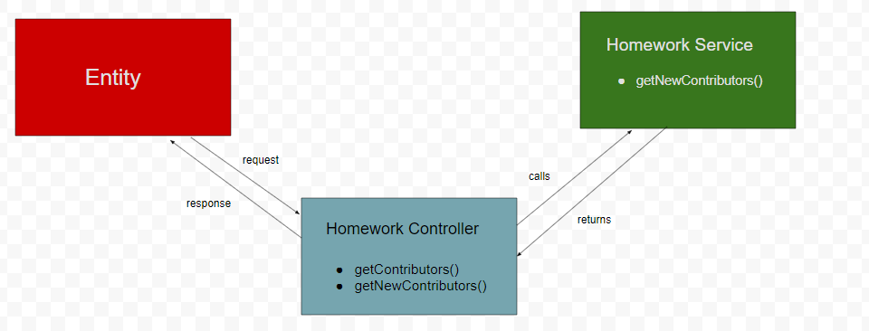

getContributors() - gets all the contributors to a repository and along with that specifies the date of initial commit. We have used the Octonode api client to access Github Api v3.

getNewContributors() - gets all the new contributors to a repository and the date they started contributing to the repository.

Tools and Technologies:

- NEST JS
- GITHUB API V3
- OCTONODE

